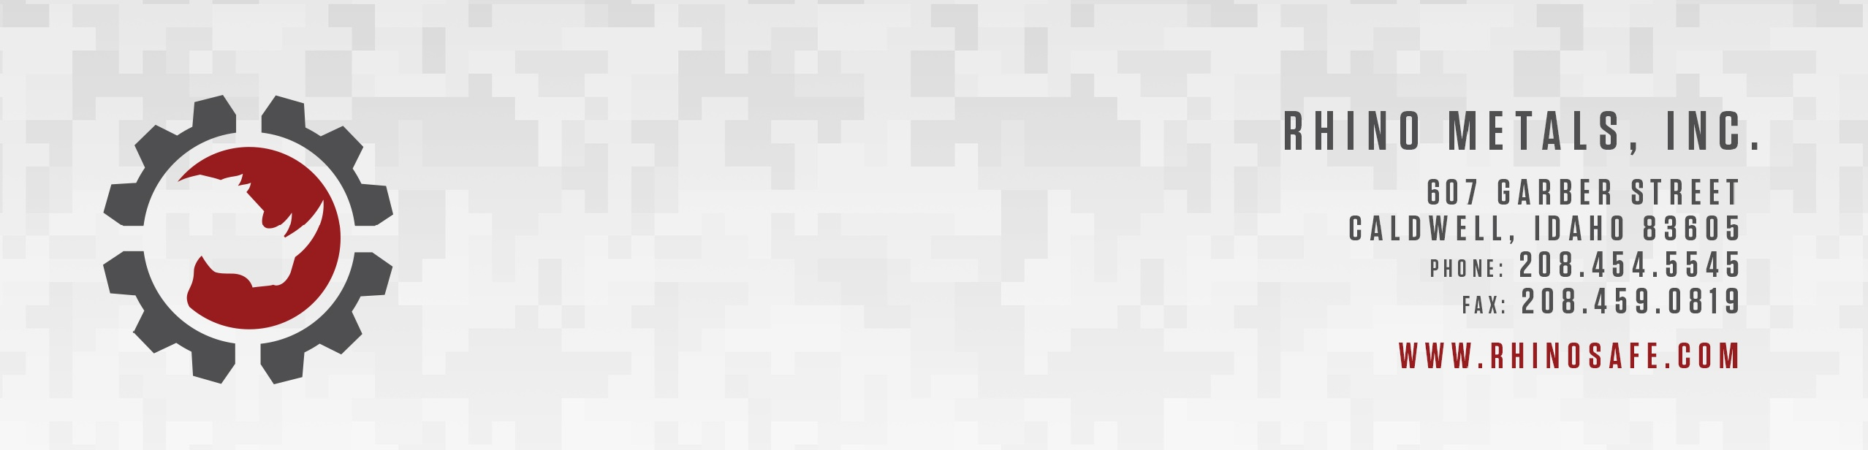

Mr. Oscar Jimenez April 20, 2024
AIMl Robotics Consulting Services
San Jose, Costa Rica

Hello Oscar,

Thank you for talking with me on the phone to discuss your company’s AI focused consulting services. To briefly recap, we are looking for ways to employ AI to improve our processes, for growth and to develop a strong competitive advantage in our industries.
The prospect of integrating AI and automation into our trucking division (Fox2 Transport LLC) using weather observations and forecasts for generating optimum route selection, and AI driven methods for optimizing backhaul revenue is promising. Your experience as an AI coder and consultant will be extremely valuable in our endeavors and is a unique mix of experience tailored to needs.
Our manufacturing divisions (Rhino Metals, Inc. and Criterion Trailers, LLC) could also greatly benefit from your AI expertise.
We believe that with your help we can streamline processes across all our divisions, improving the efficiency and coordination throughout our vertical integration, and ultimately, driving greater value for our customers.
We would like to discuss more specific ways that AIMI can help us stay at the forefront of our industry and capitalize on the vast opportunities of AI. Please let us know your availability for a meeting or a call at your earliest convenience.

Bet Regards,

Don Suggs
CEO, Rhino Metals Inc.

